Is This Patient Hypovolemic?
[The Rational Clinical Examination]
McGee, Steven MD; Abernethy, William B. III, MD; Simel, David L. MD, MHS
JAMA Volume 281(11), 17 March 1999, pp 1022-1029
Objective: To review, systematically, the physical diagnosis of hypovolemia in adults.
Methods: We searched MEDLINE (January 1966-November 1997), personal files, and bibliographies of textbooks on physical diagnosis and identified 10 studies investigating postural vital signs or the capillary refill time of healthy volunteers, some of whom underwent phlebotomy of up to 1150 mL of blood, and 4 studies of patients presenting to emergency departments with suspected hypovolemia, usually due to vomiting, diarrhea, or decreased oral intake.
Results: When clinicians evaluate adults with suspected blood loss, the most helpful physical findings are either severe postural dizziness (preventing measurement of upright vital signs) or a postural pulse increment of 30 beats/min or more. The presence of either finding has a sensitivity for moderate blood loss of only 22% (95% confidence interval [CI], 6%-48%) but a much greater sensitivity for large blood loss (630 – 1150 ml) of 97% (95% CI, 91%-100%); the corresponding specificity is 98% (95% CI, 97%-99%). Supine hypotension and tachycardia are frequently absent, even after up to 1150 mL of blood loss (sensitivity, 33%; 95% CI, 21%-47%, for supine hypotension). The finding of mild postural dizziness has no proven value. In patients with vomiting, diarrhea, or decreased oral intake, the presence of a dry axilla supports the diagnosis of hypovolemia (positive likelihood ratio, 2.8; 95% CI, 1.4-5.4), and moist mucous membranes and a tongue without furrows argue against it (negative likelihood ratio, 0.3; 95% CI, 0.1-0.6 for both findings). In adults, the capillary refill time and poor skin turgor have no proven diagnostic value.
Conclusions: A large postural pulse change (>or= to 30 beats/min) or severe postural dizziness is required to clinically diagnose hypovolemia due to blood loss, although these findings are often absent after moderate amounts of blood loss. In patients with vomiting, diarrhea, or decreased oral intake, few findings have proven utility, and clinicians should measure serum electrolytes, serum blood urea nitrogen, and creatinine levels when diagnostic certainty is required.
JAMA.1999;281:1022-1029

The Rational Clinical Examination Section Editors:David L. Simel, MD, MHS, Durham Veterans Affairs Medical Center and Duke University Medical Center, Durham, NC; Drummond Rennie, MD, Deputy Editor (West), JAMA.
CLINICAL SCENARIOS
In each of the following clinical scenarios, clinicians need to identify which physical signs reliably and accurately indicate volume depletion or dehydration.
Case 1
A 54-year-old man, taking ibuprofen for knee arthritis, presents with a 1-day history of melena. Physical examination reveals a pulse of 80/min and blood pressure (BP) of 140/82 mm Hg when supine, and 115 and 132/86 mm Hg when standing. There is mild epigastric tenderness and hemoccult-positive stool. The hematocrit is 0.39.
Case 2
A 62-year-old woman has 6 months of episodic vertigo and unilateral hearing loss, attributed to Meniere disease. She begins treatment with hydrochlorothiazide, but during a follow-up visit 3 weeks later, she reports her dizziness is slightly worse since starting the medication. Her heart rate is 80/min and BP is 160/84 mm Hg when supine, 88 and 134/72 mm Hg when standing. She experiences slight dizziness when standing.
Case 3
An 82-year-old nursing home resident presents to the emergency department with a 1-day history of nausea and vomiting. Her underlying medical problems include dementia, coronary artery disease, atrial fibrillation, emphysema, and hypertension. She has been treated with aspirin, isosorbide dinitrate, furosemide, beta-agonist inhalers, and lisinopril. The clinician diagnoses viral gastroenteritis or food poisoning because other members of the nursing home have an identical illness. On examination, the patient is afebrile, alert, and demonstrates normal speech and strength. Her mental status is no different from her baseline. The pulse is 75/min and the BP is 154/90 mm Hg supine, and 90 and 130/76 mm Hg when upright. The tongue, mucous membranes, and axillae are moist. Results of an examination of the heart, lungs, and abdomen and an electrocardiogram are normal.
WHY IS CLINICAL EXAMINATION IMPORTANT?
The term volume depletion describes the loss of sodium from the extracellular space (intravascular and interstitial fluid) that occurs after gastrointestinal hemorrhage, vomiting, diarrhea, and diuresis. In contrast, the term dehydration refers to losses of intracellular water that ultimately cause cellular desiccation and elevate the plasma sodium concentration and osmolality. [1] This distinction is important to clinicians (patients with volume depletion exhibit prominent circulatory instability and should receive 0.9% saline rapidly, whereas those with pure dehydration may lack circulatory instability and should receive 5% dextrose, usually more slowly). Most patients presenting with dehydration, however, also have volume depletion. Moreover, in most clinical studies of related physical findings, investigators lump the 2 disorders together, by using as a combined criterion standard either the presence of an elevated serum urea nitrogen-creatinine ratio (a measure of volume depletion) or an elevated serum sodium level or osmolality (a measure of dehydration). We will use the term hypovolemia to collectively refer to both conditions.
Gastrointestinal tract hemorrhage, the prototype of volume depletion, is a common and important problem. Hospitalizations for upper gastrointestinal tract hemorrhage occur in 150/100,000 population per year [2] and are associated with a case fatality rate of 3% to 10%. [2,3] Hypernatremia, the hallmark of dehydration, affects primarily elderly patients with infections and poor access to water, accounting for less than 1% of hospital admissions but associated with a mortality rate exceeding 40%. [4,5] Risk factors for hypovolemia in the elderly include female sex, age older than 85 years, having more than 4 chronic medical conditions, taking more than 4 medications, and being confined to bed. [6]
Clinical examination attempts to address (1) whether the patient's symptoms are related to hypovolemia and (2) how severely hypovolemic the patient is. In case 1, symptoms and laboratory data do not gauge the severity of the gastrointestinal tract hemorrhage. For example, the presence of melena has been associated with both insignificant (as little as 100 mL of blood loss) [7] and massive hemorrhage. [8] The admission hematocrit also correlates poorly with the degree of blood loss and overall mortality, [3-10] especially in cases of persistent or recurrent bleeding, because a decrease in hematocrit is often delayed 24 to 72 hours after hemorrhage. [11-13] In 1 large study, [3] however, postural vital signs were a significant univariate predictor of mortality and complications. By influencing decisions to hospitalize the patient with hemorrhage, perhaps even in the intensive care unit, postural vital signs may be useful to the clinician. But how accurate are they and which component of the postural change, pulse or BP, provides more meaningful information?
In case 2, the clinician recognizes that hydrochlorothiazide may benefit patients with Meniere disease [14] but also wonders if the diuretic could be causing volume depletion and aggravating her dizziness. How significant is the postural decrease in systolic BP of 26 mm Hg and the mild postural dizziness?
Finally, case 3 differs from case 1 in that the fluid losses are not directly from the vascular space and that emesis typically has only one third the sodium concentration of serum. How reliable are findings of postural vital signs, capillary refill, and moist axilla, tongue, and mucous membranes in this patient?
METHODS
Using the MEDLINE database for articles from January 1966 to November 1997, an author (S.M.) used 3 search strategies, all limited to the English language and to humans 16 years or older, to retrieve all relevant publications on the bedside diagnosis of hypovolemia. The first strategy used the search terms dehydration/di or hypotension, orthostatic or tilt-Table test. The second strategy used exp dehydration or exp hypotension, orthostatic or exp heart rate and exp physical examination or exp medical history taking or exp professional competence or exp "sensitivity and specificity" or reproducibility of results or observer variation or diagnostic tests, routine or exp decision support techniques or Bayes theorem. Finally, textword searches were completed for skin turgor or acute blood loss or orthostatic vital signs or (postural and pulse). Based on review of titles and abstracts, relevant publications were retrieved. To complete the search, this author reviewed the bibliographies of these articles and those of textbooks on physical diagnosis. Studies of the physical diagnosis of hypovolemia in infants and children were not included in this review. [15-23]
Two types of studies are presented. The first group (Table 1) investigated the postural vital signs and capillary refill time in healthy volunteers, some of whom underwent phlebotomy of up to 1150 mL of blood. Despite their limitations, these studies are included because they are the only studies that compare physical signs with objective measurements of blood loss. A second set (Table 2) included patients presenting to emergency departments with suspected hypovolemia, usually due to vomiting, diarrhea, or decreased oral intake. Two authors (S.M. and W.B.A.) independently graded these studies A, B, or C, according to the criteria that appear in the footnote of (Table 2). There was complete agreement regarding classification.

Table 1
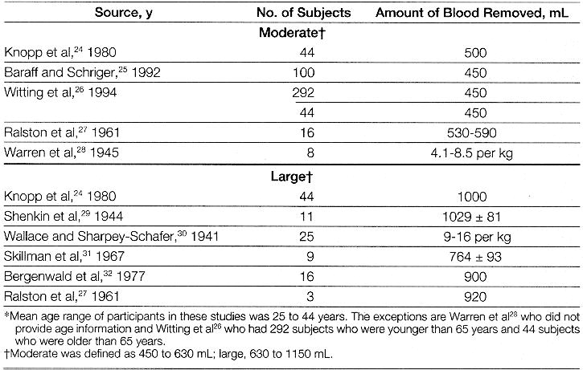

Table 2
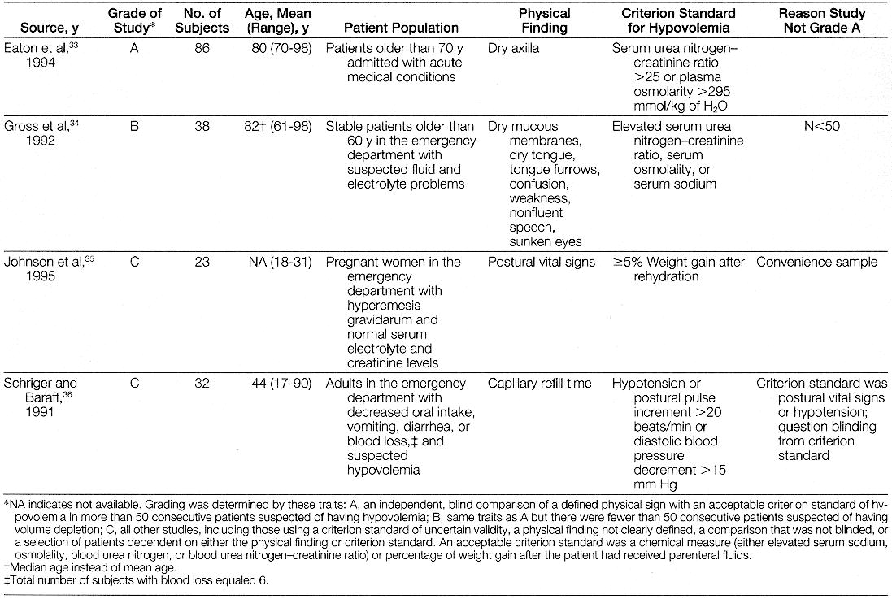
A random effects model was used to generate summary measures and confidence intervals (CIs). [37,38] The model was appropriate because the studies of pulse and pressure change in normovolemic individuals were representative of all such investigations and included a broad mix of relevant subjects. For studies of diagnostic accuracy, the random effects summary measures provided suitable benchmarks for clinicians' use in actual practice and avoided errors when testing for homogeneity among a number of investigations. Calculations of sensitivity and specificity derive from graphs or tabulated data that appear in the original article or were available from the authors of the studies. [26,34,35] Those phlebotomy studies that described their results only as mean and SDs of the postural change in heart rate and BP, before and after phlebotomy, were reviewed but excluded from the calculations of sensitivity and specificity. [39-42] We used the method of Simel et al [43] to calculate CIs for the likelihood ratios (LRs).
Results
Postural Vital Signs
When obtaining postural vital signs, clinicians should wait 2 minutes before measuring the supine vital signs and 1 minute after standing before measuring the upright vital signs, based on investigations of healthy individuals discussed below. Sitting instead of standing up the patient markedly reduces the clinician's ability to detect the postural changes induced by blood loss. [24] Clinicians who count the pulse for 30 seconds and double the result are more accurate than those using only 15 seconds. [44]
Within 1 to 2 minutes after standing up from the supine position, about 7 to 8 mL/kg of blood shifts to the lower body, causing the thoracic blood volume, stroke volume, and cardiac output to decrease and circulating norepinephrine levels and systemic vascular resistance to increase. [40,41,45-48] As revealed in (Table 3), which presents data from 25 studies that investigated the postural vital signs of more than 3500 normovolemic individuals (ie, during the tilt test, moving from supine to upright positions by active standing in 97%, by tilt Table in 3%), the most prominent finding is an increment in heart rate of 10.9/min (95% CI, 8.9-12.8/min). This increase usually stabilizes after 45 to 60 seconds in the upright position. [24,45,52,54] The systolic BP drops slightly by 3.5 mm Hg (95% CI, -1.5 to -5.5 mm Hg), stabilizing 1 to 2 minutes after standing, [45,54] whereas the diastolic BP increases by 5.2 mm Hg (95% CI, 2.8-7.6 mm Hg).

Table 3
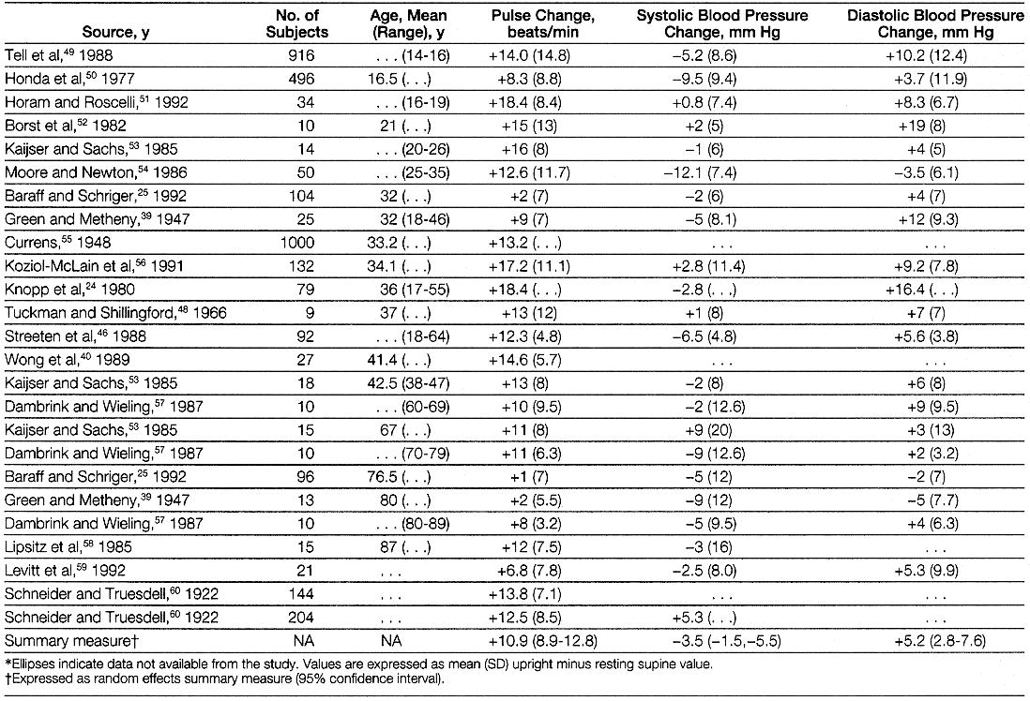
Table 3. Postural Change in Vital Signs of Normovolemic Adults

The variability of the postural pulse increment observed in these studies is in part attributable to the patients' ages and perhaps to the physical examination method. In (Table 3), the mean age from each study correlates inversely with the observed mean pulse increment (r, -0.50; P =.02; (Table 3)). Other studies [47,56,57,61,62] also confirm that as patients age, the pulse increment becomes smaller, although no obvious cutpoint exists that allows the clinician to stratify patients. The duration of supine rest before the patient stands might also affect variability of the pulse change, based on the 1 outlier study in (Table 3), [25] which demonstrated a mean postural pulse increment of only 2 beats/min and used the shortest time of supine rest before having the patient stand (only 1 minute; all other studies waited at least 2 minutes). Longer periods of supine rest before standing may produce a greater immediate pulse increment, perhaps by causing a greater transfer of blood to the legs and decrement in cardiac output. [48,63] Aside from the patient's age and period of supine rest, however, no other trend was evident. There was no clear relationship between the postural pulse increment and period of supine rest beyond 2 minutes, resting supine pulse rate, time upright before vital signs measurement (all >45 seconds), technique of pulse measurement (palpation vs automated), setting of the study (emergency department, prephlebotomy vs other), or method of assuming the upright posture (active stand vs tilt table).
Based on the studies in (Table 3) that enrolled more than 25 individuals and presented tabulated data (n = 774), the specificity of a postural pulse increment of 30/min or more (ie, the most common threshold used in clinical studies) was 96% (95% CI, 92%-98%).
Postural hypotension, defined as a decrement in systolic BP of more than 20 mm Hg after standing from the supine position, occurs in up to 10% of normovolemic individuals younger than 65 years [26] and in 11% to 30% older than 65 years. [64-71] Postural hypotension is more likely if the patient has supine systolic hypertension, [58,67,68,71-73] but is not more likely, surprisingly, if the patient takes cardiovascular or psychotropic medications. [47,65,68,71,74] Finally, the symptom of mild or moderate postural dizziness is a poor predictor of postural hypotension in most studies. [56,67,70]
Pathogenesis and Definition of Other Physical Findings
The capillary refill time is determined by compressing the distal phalanx of the patient's middle finger, positioned level with the heart, for 5 seconds and then timing the return of normal color to the finger. With an ambient temperature of 21 degrees C, the upper limits of normal for the refill time are 2 seconds for children and adult men, 3 seconds for adult women, and 4 seconds for the elderly. [75]
Poor skin turgor refers to the slow return of skin to its normal position after being pinched between the examiner's thumb and forefinger. [76] The protein elastin, which is responsible for the recoil of skin, is markedly affected by moisture content. As little as 3.4% loss in wet weight may prolong the recoil time 40-fold. [76] Elastin deteriorates with age, suggesting that the recoil of skin normally declines with age, although this has never been formally studied to the authors' knowledge. No studies on the normal recoil time nor precise definitions of technique could be found.
Cellular dehydration, interstitial space dehydration, and poor perfusion are presumably responsible for many of the other classic signs of hypovolemia, such as longitudinal tongue furrows, dry mucous membranes, dry axillae, and sunken eyes. No studies on the pathogenesis of these findings, however, could be found.
Precision of Physical Signs
Reproducible measurements of BP depend on many variables, including the examiner's technique, the patient examined, and various observer biases and errors, all of which are thoroughly reviewed in another article. [77]
Outside of an extensive literature devoted to patients with syncope that uses different methods and end points than those discussed in this article, the few studies of tilt test reproducibility focus more on biological variation (ie, reproducibility of the test when repeated days later) than on immediate interobserver reproducibility. In 1 study, which measured postural vital signs of 911 elderly nursing home residents 4 times during the day, postural hypotension was present only 1 of the 4 times in 18.3% of the residents, 2 or 3 times in 19.9%, and all 4 times in only 13.3%. [68] Postural hypotension is more reproducible in the morning than afternoon [68,78] or if the patient's cardiovascular medications are withheld (which tends to unmask supine systolic hypertension, a known risk factor for postural hypotension). [58,73]
In acutely ill elderly patients, interobserver agreement for axillary sweating (dry vs moist) was moderate (kappa, 0.50; 80% simple agreement). [33] In addition, the clinician's assessment of axillary moisture correlated well with the weight gain of a piece of preweighed tissue paper applied to the patient's axilla for 15 minutes. [33] Using stopwatches, the measurements of capillary refill time by 2 observers were within 0 to 0.3 seconds of each other. [75]
Accuracy of Physical Signs for Acute Blood Loss
(Table 4) reveals that the 2 most valuable observations from the tilt test are either a postural pulse increment of 30/min or more or the inability of the patient to stand for vital signs because of severe dizziness. After blood loss of 450 to 630 mL, only 1 in 5 patients demonstrate these findings. The sensitivity increases to 97% (95% CI, 91%-100%) after 630 mL to 1150 mL blood loss. The specificity is 98% (95% CI, 97%-99%), a value similar to that generated from the studies in (Table 3). Either of these findings is durable after hemorrhage, lasting at least 12 to 72 hours if intravenous fluids are withheld. [11,30,39] If the patient sits instead of stands up from the supine position, the sensitivity decreases, being 39% [24] and 78% [30] in 2 studies after 1000 mL of hemorrhage. Because the studies of large blood loss (630-1150 mL) enrolled younger healthy individuals, the sensitivity may also be lower in elderly patients or those taking medications such as beta-blockers. The patient complaint of postural dizziness, not severe enough to prevent standing and accompanied by a pulse increment lower than 30/min, has little predictive value. [26,56]

Table 4
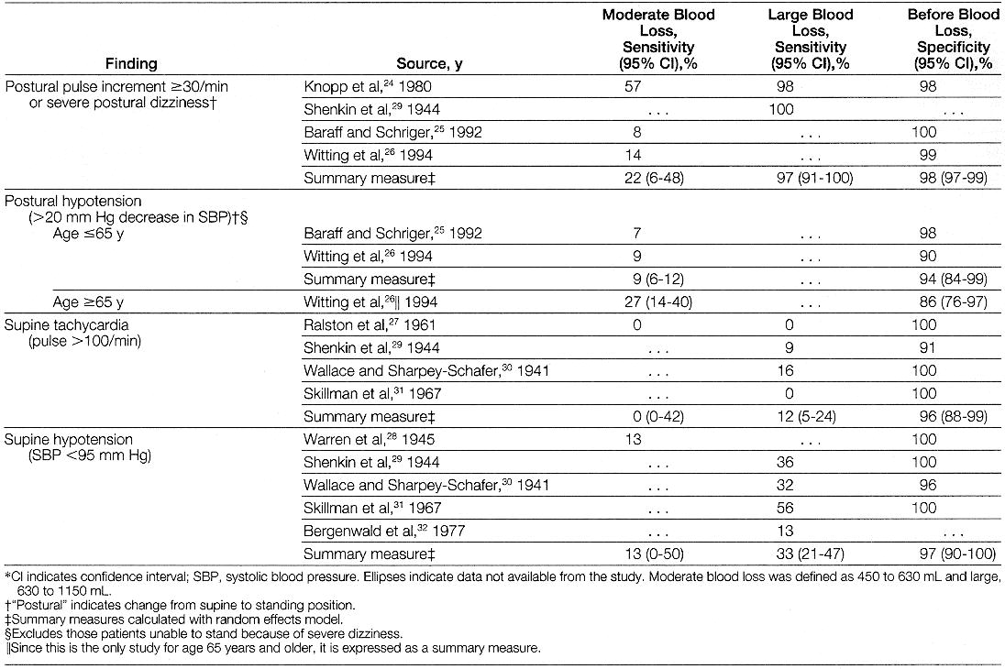
Table 4. Diagnostic Accuracy of Vital Signs for Acute Blood Loss

After excluding those unable to stand for vital signs, postural hypotension (a more than 20-mm Hg decrease in systolic BP) has little additional predictive value. Its sensitivity for 450 to 630 mL of blood loss is only 9% in those younger than 65 years and 27% in those older than 65 years. These numbers are similar to the false-positive rates in some studies of the same age groups, 10% (<65 years) [26] and 28% (>65 years), [71] resulting in positive LRs close to unity. There are insufficient data to address the value of isolated postural hypotension after 630 to 1150 mL of blood loss.
Supine tachycardia (pulse >100/min) is a specific but insensitive indicator of blood loss (96% specificity). Thus, patients without supine tachycardia can still have significant blood loss. In contrast, bradycardia occurs frequently after significant blood loss, often immediately preceding the decrease in systemic vascular resistance and the fainting that may occur. [11,27-32,39,79-81] One study [80] showed a strong correlation between the decrease in heart rate after blood loss and the maximal decrease in BP (r, 0.79), and, in hypotensive patients receiving fluid resuscitation, the pulse may paradoxically rise initially. [81]
In patients with suspected blood loss, supine hypotension (systolic BP <95 mm Hg) is a specific finding of hypovolemia (97% specificity), although it is insensitive to both moderate blood loss of 450 to 630 mL (13% sensitivity) and more significant loss of 630 to 1150 mL (33% sensitivity).
Using the age- and sex-specific upper limits of normal for capillary refill time defined earlier, a prolonged refill time does not accurately predict 450 mL of blood loss (6% sensitivity and 93% specificity) and yields a positive LR of 1.0. [36] If the clinician instead uses an arbitrary upper limit of 2 seconds, diagnostic performance is no better (11% sensitivity, 89% specificity, positive LR, 1.0). [36]
Accuracy of Physical Signs for Other Causes of Hypovolemia
(Table 5) reviews the sensitivity and specificity of various physical signs for the diagnosis of hypovolemia derived from studies of individuals usually presenting to emergency departments with vomiting, decreased oral intake, or diarrhea. Except for 1 study, [35] which enrolled young women with hyperemesis gravidarum, these studies generally recruited older adults.

Table 5
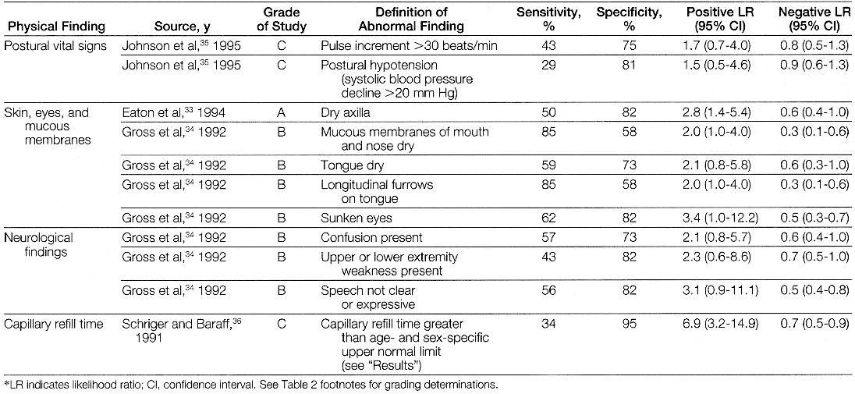

The finding of a dry axilla increases the probability of hypovolemia (positive LR, 2.8; 95% CI, 1.4-5.4), although it is an insensitive physical sign (50% sensitivity). [33] The finding of a moist axilla decreases the probability of volume depletion only slightly (negative LR, 0.6; 95% CI, 0.4-1.0).
In the study by Johnson et al [35] of 23 women with hyperemesis gravidarum, neither postural hypotension nor a postural pulse increment of more than 30/min was particularly helpful (Table 5). In this study, however, the specificity of a pulse increment of more than 30/min was unusually low (75%). One possible reason for this could be the authors' definition of dehydration (>or= to 5% weight gain after 12 hours of rehydration), which led them to classify as nondiseased the dehydrated women with less than 5% weight gain, thus devaluing the specificity calculation. Alternatively, the postural pulse increment may be less specific because of pregnancy.
In another study of 202 individuals with acute illnesses, investigators used multiple analysis of variance to identify which clinical findings best explained the variation in total body water deficit, as calculated from the patient's serum osmolality. [59] The finding of a dry axilla was significantly associated with level of dehydration (P =.03). The postural pulse increment was also significantly associated but only weakly so (r, 0.22; P =.02). [59] The mean water deficit in this study was only 3.9%, correlating with a 140-mL deficit from the vascular space (or about 250 mL of blood), a level below that in the phlebotomy studies discussed earlier. This study found no association between dehydration and postural changes of systolic BP.
In (Table 5), the capillary refill time seems to perform impressively, especially when the capillary refill time is prolonged (positive LR, 6.9). [36] However, the criterion standard in this study was the supine and postural vital signs, raising the question whether capillary refill time has any incremental diagnostic value. Another study found no correlation between capillary refill time, tested over the patella, and objective measures of hypovolemia. [34]
In a study of 55 elderly patients presenting with suspected hypovolemia, the 7 physical signs of confusion, extremity weakness, nonfluent speech, dry mucous membranes, dry tongue, furrowed tongue, and sunken eyes correlated best with measurement of the serum sodium and serum urea nitrogen-creatinine ratio (Table 5). [34] Based on the CIs of the LRs, however, none of these findings is particularly helpful when present in isolation. Combinations of findings may be more helpful-on average, patients with severe and moderate hypovolemia had 5.7 and 3.9, respectively, of these 7 signs, whereas those without dehydration had only 1.3-but this requires validation. [34] The most helpful negative findings, arguing against hypovolemia, are moist mucous membranes, absence of sunken eyes, and absence of furrows on the tongue.
Another study found no correlation between degree of hypovolemia and dryness of mucous membranes. [59] In adults, 2 studies have found poor skin turgor to have no diagnostic value. [34,59]
The Bottom Line
When obtaining postural vital signs, clinicians should wait at least 2 minutes before measuring the supine vital signs and 1 minute after standing before measuring the upright vital signs. Counting the pulse for 30 seconds and doubling the result is more accurate than 15 seconds of observation. [44] In normovolemic individuals, a postural pulse increment of more than 30 beats/min is uncommon, affecting only about 2% to 4% of individuals.
When evaluating patients with suspected blood loss, the most helpful physical findings are severe postural dizziness (preventing measurement of upright vital signs) or a postural pulse increment of 30 beats/min or more. Having the patient sit instead of stand reduces the sensitivity of the tilt test. After excluding those unable to stand, postural hypotension has no incremental diagnostic value.
Supine hypotension and tachycardia are frequently absent, even with more than 1000 mL of blood loss, and the symptom of mild postural dizziness has no proven diagnostic value. Bradycardia is common after significant blood loss.
Rigorous conclusions about the role of physical examination in assessing the volume and hydration status of patients with vomiting, diarrhea, or decreased oral intake are difficult to make because there are few studies. Severe postural dizziness or a postural pulse increment of 30 beats/min or more should be just as accurate as after blood loss, although 1 study of the pulse increment in patients with hyperemesis gravidarum failed to confirm this. A dry axilla supports the diagnosis of hypovolemia in the elderly, and moist mucous membranes and a tongue without furrows argue against it. However, clinicians should recall that the criterion standard of hypovolemia in these studies-simple serum chemistry measurements-is easily accessible to clinicians. When applying these findings to practice, until further data are available, clinicians should have a low threshold for ordering tests of serum electrolytes, serum blood urea nitrogen, and creatinine. In adults, the capillary refill time and poor skin turgor have no proven diagnostic value.
Case 1 demonstrates a postural pulse increment of more than 30 beats/min, suggesting significant blood loss. The clinician should admit this patient to the hospital for fluid resuscitation and further testing. In case 2, postural hypotension and mild postural dizziness lack the specificity necessary to condemn the diuretic at this time. The clinician should continue the diuretic if he believes the patient's dizziness resembles inner-ear vertigo. Finally, despite the negative physical examination findings in case 3, this patient has many risk factors for significant hypovolemia, and the clinician should measure the serum blood urea nitrogen, creatinine, and electrolytes before making the decision to discharge the patient.
Acknowledgment: We thank Kenneth Goldberg, MD, and Bill Yarger, MD, for their comments.
Corresponding Author and Reprints: Steven McGee, MD, University of Washington, Seattle-Puget Sound VA Health Care System (111), 1660 S Columbian Way, Seattle, WA 98108.
REFERENCES
1. Mange K, Matsuura D, Cizman B, et al. Language guiding therapy: the case of dehydration versus volume depletion. Ann Intern Med. 1997;127:848-853. [Context Link]
2. Cutler JA, Mendeloff AI. Upper gastrointestinal bleeding: nature and magnitude of the problem. Dig Dis Sci. 1981;26(suppl):90S-96S. Bibliographic Links [Context Link]
3. Silverstein FE, Gilbert DA, Tedesco FJ, et al. The national ASGE survey on upper gastrointestinal bleeding, II. Gastrointest Endosc. 1981;27:80-93. [Context Link]
4. Palevsky PM, Bhagrath R, Greenberg A. Hypernatremia in hospitalized patients. Ann Intern Med. 1996;124:197-203. Ovid Full Text Bibliographic Links [Context Link]
5. Snyder NA, Feigal DW, Arieff AI. Hypernatremia in elderly patients. Ann Intern Med. 1987;107:309-319. Bibliographic Links [Context Link]
6. Lavizzo-Mourey R, Johnson J, Stolley P. Risk factors for dehydration among elderly nursing home residents. J Am Geriatr Soc. 1988;36:213-218. Bibliographic Links [Context Link]
7. Schiff L, Stevens RJ, Shapiro N, Goodman S. Observations on the oral administration of citrated blood in man, II. Am J Med Sci. 1942;203:409-412. [Context Link]
8. Wara P, Stodkilde H. Bleeding pattern before admission as guideline for emergency endoscopy. Scand J Gastroenterol. 1985;20:72-78. [Context Link]
9. Tibbs DJ, Leslie WG. Blood volumes in gastroduodenal haemorrage. Lancet. 1956;2:266-274. [Context Link]
10. Schiller KFR, Truelove SC, Williams DG. Haematemesis and melaena, with special reference to factors influencing the outcome. BMJ. 1970;2:7-14. [Context Link]
11. Ebert RV, Stead EA, Gibson JG. Response of normal subjects to acute blood loss. Arch Intern Med. 1941;68:578-590. [Context Link]
12. Taylor PH, Heydinger DK, Bowers JO, Callendine GW. Evaluation of small acute blood loss in man. Am J Surg. 1967;114:913-916. Bibliographic Links [Context Link]
13. Bennett TI, Dow J, Lander L, Wright S. Severe haemorrhage from the stomach and duodenum. Lancet. 1938;2:651-655. [Context Link]
14. Klockhoff I, Lindblom U. Meniere's disease and hydrochlorothiazide. Acta Otolaryngol (Stockh). 1967;63:347-365. [Context Link]
15. Bergman GE, Reisner FF, Anwar RAH. Orthostatic changes in normovolemic children: an analysis of the "tilt test.". J Emerg Med. 1983;1:137-141. [Context Link]
16. Castro W, Skarin R, Roscelli JD. Orthostatic heart rate and arterial blood pressure changes in normovolemic children. Pediatr Emerg Care. 1985;1:123-127. [Context Link]
17. Duggan C, Refat M, Hashem M, et al. How valid are clinical signs of dehydration in infants?. J Pediatr Gastroenterol Nutr. 1996;22:56-61. Ovid Full Text Bibliographic Links [Context Link]
18. Fuchs SM, Jaffe DM. Evaluation of the "tilt test" in children. Ann Emerg Med. 1987;16:386-390. Bibliographic Links [Context Link]
19. Laron Z. Skin turgor as a quantitative index of dehydration in children. Pediatrics. 1957;19:816-822. [Context Link]
20. Mackenzie A, Barnes G, Shann F. Clinical signs of dehydration in children. Lancet. 1989;2:605-607. Bibliographic Links [Context Link]
21. Paxton LA, Redd SC, Steketee RW, et al. An evaluation of clinical indicators for severe paediatric illness. Bull World Health Organ. 1996;74:613-618. Bibliographic Links [Context Link]
22. Saavedra JM, Harris GD, Li S, Finberg L. Capillary refilling skin turgor in the assessment of dehydration. AJDC. 1991;145:296-298. Bibliographic Links [Context Link]
23. Yurdakok K. Dry cry: a new definition for old criteria in dehydrated children. Arch Pediatr Adolesc Med. 1997;151:208-209. [Context Link]
24. Knopp R, Claypool R, Leonardi D. Use of the tilt test in measuring acute blood loss. Ann Emerg Med. 1980;9:72-75. [Context Link]
25. Baraff LJ, Schriger DL. Orthostatic vital signs: variation with age, specificity, and sensitivity in detecting a 450-mL blood loss. Am J Emerg Med. 1992;10:99-103. Bibliographic Links [Context Link]
26. Witting MD, Wears RL, Li S. Defining the positive tilt test. Ann Emerg Med. 1994;23:1320-1323. Bibliographic Links [Context Link]
27. Ralston LA, Cobb LA, Bruce RA. Acute circulatory effects of arterial bleeding as determined by indicator-dilution curves in normal human subjects. Am Heart J. 1961;61:770-776. [Context Link]
28. Warren JV, Brannon ES, Stead EA, Merrill AJ. The effect of venesection and the pooling of blood in the extremities on the atrial pressure and cardiac output in normal subjects with observations on acute circulatory collapse in three instances. J Clin Invest. 1945;24:337-344. [Context Link]
29. Shenkin HA, Cheney RH, Govons SR, Hardy JD, Fletcher AG, Starr I. On the diagnosis of hemorrhage in man. Am J Med Sci. 1944;208:421-436. [Context Link]
30. Wallace J, Sharpey-Schafer EP. Blood changes following controlled haemorrhage in man. Lancet. 1941;241:393-395. [Context Link]
31. Skillman JJ, Olson JE, Lyons JH, Moore FD. The hemodynamic effect of acute blood loss in normal man, with observations on the effect of the valsalva maneuver and breath holding. Ann Surg. 1967;166:713-738. Bibliographic Links [Context Link]
32. Bergenwald L, Freyschuss U, Sjostrand T. The mechanism of orthostatic and haemorrhage fainting. Scand J Clin Lab Invest. 1977;37:209-216. [Context Link]
33. Eaton D, Bannister P, Mulley GP, Conolly MJ. Axillary sweating in clinical assessment of dehydration in ill elderly patients. BMJ. 1994;308:1271. Ovid Full Text Bibliographic Links [Context Link]
34. Gross CR, Lindquist RD, Woolley AC, et al. Clinical indicators of dehydration severity in elderly patients. J Emerg Med. 1992;10:267-274. Bibliographic Links [Context Link]
35. Johnson DR, Douglas D, Hauswald M, Tandberg D. Dehydration and orthostatic vital signs in women with hyperemesis gravidarum. Acad Emerg Med. 1995;2:692-697. [Context Link]
36. Schriger DL, Baraff LJ. Capillary refill: is it a useful predictor of hypovolemic states?. Ann Emerg Med. 1991;20:601-605. Bibliographic Links [Context Link]
37. Eddy DM, Hasselblad V, Shachter RD. Meta-Analysis by the Confidence Profile Method: The Statistical Synthesis of Evidence. San Diego, Calif: Academic Press Inc; 1992:93-98. [Context Link]
38. Eddy DM, Hasselblad V. Fast*Pro v1.8: Software for Meta-Analysis by the Confidence Profile Method. San Diego, Calif: Academic Press Inc; 1992:176-177. [Context Link]
39. Green DM, Metheny D. The estimation of acute blood loss by the tilt test. Surg Gynecol Obstet. 1947;84:1045-1050. [Context Link]
40. Wong DH, O'Connor D, Tremper KK, et al. Changes in cardiac output after acute blood loss and position change in man. Crit Care Med. 1989;17:979-983. Bibliographic Links [Context Link]
41. Velasquez MT, Menitove JE, Skelton MM, Cowley AW. Hormonal responses and blood pressure maintenance in normal and hypertensive subjects during acute blood loss. Hypertension. 1987;9:423-428. Ovid Full Text Bibliographic Links [Context Link]
42. Triedman JK, Cohen RJ, Saul JP. Mild hypovolemic stress alters autonomic modulation of heart rate. Hypertension. 1993;21:236-247. Ovid Full Text Bibliographic Links [Context Link]
43. Simel DL, Samsa GP, Matchar DB. Likelihood ratios with confidence. J Clin Epidemiol. 1991;44:763-770. Bibliographic Links [Context Link]
44. Hollerbach AD, Sneed NV. Accuracy of radial pulse assessment by length of counting interval. Heart Lung. 1990;19:258-264. Bibliographic Links [Context Link]
45. Smith JJ, Porth CM, Erickson M. Hemodynamic response to the upright posture. J Clin Pharmacol. 1994;34:375-386. Bibliographic Links [Context Link]
46. Streeten DHP, Anderson GH, Richardson R, Thomas FD. Abnormal orthostatic changes in blood pressure and heart rate in subjects with intact sympathetic nervous function: evidence for excessive venous pooling. J Lab Clin Med. 1988;111:326-335. Bibliographic Links [Context Link]
47. Jansen RW, Lenders JW, Thien T, Hoefnagels WH. The influence of age and blood pressure on the hemodynamic and humoral response to head-up tilt. J Am Geriatr Soc. 1989;37:528-532. [Context Link]
48. Tuckman J, Shillingford J. Effect of difference degrees of tilt on cardiac output, heart rate, and blood pressure in normal man. Br Heart J. 1966;28:32-39. [Context Link]
49. Tell GS, Prineas RJ, Gomez-Marin O. Postural changes in blood pressure and pulse rate among black adolescents and white adolescents. Am J Epidemiol. 1988;128:360-369. Bibliographic Links
50. Honda K, Nose T, Yoshida N, Tanimura M, Tanaka K. Responses to the postural change and orthostatic dysregulation symptoms. Jpn Circ J. 1977;41:629-641.
51. Horam WJ, Roscelli JD. Establishing standards of orthostatic measurements in normovolemic adolescents. AJDC. 1992;146:848-851. Bibliographic Links
52. Borst C, Wieling W, van Brederode JFM, et al. Mechanisms of initial heart rate response to postural change. Am J Physiol. 1982;243:H676-H681. Bibliographic Links [Context Link]
53. Kaijser L, Sachs C. Autonomic cardiovascular responses in old age. Clin Physiol. 1985;5:347-357. Bibliographic Links
54. Moore KI, Newton K. Orthostatic heart rates and blood pressures in healthy young women and men. Heart Lung. 1986;15:611-617. Bibliographic Links [Context Link]
55. Currens JH. A comparison of the blood pressure in the lying and standing positions. Am Heart J. 1948;35:646-654.
56. Koziol-McLain J, Lowenstein SR, Fuller B. Orthostatic vital signs in emergency department patients. Ann Emerg Med. 1991;20:606-610. Bibliographic Links [Context Link]
57. Dambrink JHA, Wieling W. Circulatory response to postural change in healthy male subjects in relation to age. Clin Sci (Colch). 1987;72:335-341. [Context Link]
58. Lipsitz LA, Storch HA, Minaker KL, Rowe JW. Intra-individual variability in postural blood pressure in the elderly. Clin Sci (Colch). 1985;69:337-341. Bibliographic Links [Context Link]
59. Levitt MA, Lopez B, Lieberman ME, Sutton M. Evaluation of the tilt test in an adult emergency medicine population. Ann Emerg Med. 1992;21:713-718. Bibliographic Links [Context Link]
60. Schneider EC, Truesdell D. A statistical study of the pulse rate and the arterial blood pressures in recumbency, standing, and after a standard exercise. Am J Physiol. 1922;61:429-474.
61. Smith JJ, Hughes CV, Ptacin MJ, et al. The effect of age on hemodynamic response to graded postural stress in normal men. J Gerontol. 1987;42:406-411. [Context Link]
62. Patel A, Maloney A, Damato AN. On the frequency and reproducibility of orthostatic blood pressure changes in healthy community-dwelling elderly during 60-degree head-up tilt. Am Heart J. 1993;126:184-188. Bibliographic Links [Context Link]
63. Ten Harkel AD, Van Lieshout JJ, Van Lieshout EJ, Wieling W. Assessment of cardiovascular reflexes. J Appl Physiol. 1990;68:147-153. [Context Link]
64. Aronow WS, Lee NH, Sales FF, Etienne F. Prevalence of postural hypotension in elderly patients in a long-term health care facility. Am J Cardiol. 1988;62:336. Bibliographic Links [Context Link]
65. Caird FI, Andrews GR, Kennedy RD. Effect of posture on blood pressure in the elderly. Br Heart J. 1973;35:527-530. [Context Link]
66. Johnson RH, Smith AC, Spalding JMK, Wollner L. Effect of posture on blood-pressure in elderly patients. Lancet. 1965;1:731-733. [Context Link]
67. Mader SL, Josephson KR, Rubenstein LZ. Low prevalence of postural hypotension among community-dwelling elderly. JAMA. 1987;258:1511-1514. [Context Link]
68. Ooi WL, Barrett S, Hossain M, Kelley-Gagnon M, Lipsitz LA. Patterns of orthostatic blood pressure change and their clinical correlates in a frail, elderly population. JAMA. 1997;277:1299-1304. Ovid Full Text Bibliographic Links [Context Link]
69. Palmer KT. Studies into postural hypotension in elderly patients. N Z Med J. 1983;96:43-45. [Context Link]
70. Rodstein M, Zeman FD. Postural blood pressure changes in the elderly. J Chronic Dis. 1957;6:581-588. [Context Link]
71. Raiha I, Luntonen S, Piha J, et al. Prevalence, predisposing factors, and prognostic importance of postural hypotension. Arch Intern Med. 1995;155:930-935. Bibliographic Links [Context Link]
72. MacLennan WJ, Hall MRP, Timothy JI. Postural hypotension in old age. Age Ageing. 1980;9:25-32. Bibliographic Links [Context Link]
73. Jansen RW, Kelley-Gagnon MM, Lipsitz LA. Intraindividual reproducibility of postprandial and orthostatic blood pressure changes in older nursing-home patients. J Am Geriatr Soc. 1996;44:383-389. Bibliographic Links [Context Link]
74. Myers MG, Kearns PM, Kennedy DS, Fisher RH. Postural hypotension and diuretic therapy in the elderly. CMAJ. 1978;119:581-585. Bibliographic Links [Context Link]
75. Schriger DL, Baraff L. Defining normal capillary refill. Ann Emerg Med. 1988;17:932-935. [Context Link]
76. Dorrington KL. Skin turgor: do we understand the clinical sign?. Lancet. 1981;1:264-265. Bibliographic Links [Context Link]
77. Reeves RA. Does this patient have hypertension?. JAMA. 1995;273:1211-1218. Ovid Full Text Bibliographic Links [Context Link]
78. Ward C, Kenny RA. Reproducibility of orthostatic hypotension in symptomatic elderly. Am J Med. 1996;100:418-422. Bibliographic Links [Context Link]
79. Barcroft H, Edholm OG, McMichael J, Sharpey-Schafer EP. Posthaemorrhagic fainting. Lancet. 1944;1:489-491. [Context Link]
80. Ruetz PP, Johnson SA, Callahan R, et al. Fainting: a review of its mechanisms and a study in blood donors. Medicine (Baltimore). 1967;46:363-384. Bibliographic Links [Context Link]
81. Sander-Jensen K, Secher NH, Bie P, Warberg J, Schwartz TW. Vagal slowing of the heart during haemorrhage. BMJ. 1986;292:364-366. [Context Link]
Dehydration; Hemorrhage; Hypotension, Orthostatic; THE RATIONAL CLINICAL EXAMINATION (Simel DL, Rennie D, eds); Vomiting

